**Motivational Interviewing**

* A p*urposeful and directional* way of talking to an individual about *growth and change* that strengthens *their own motivation* to change.

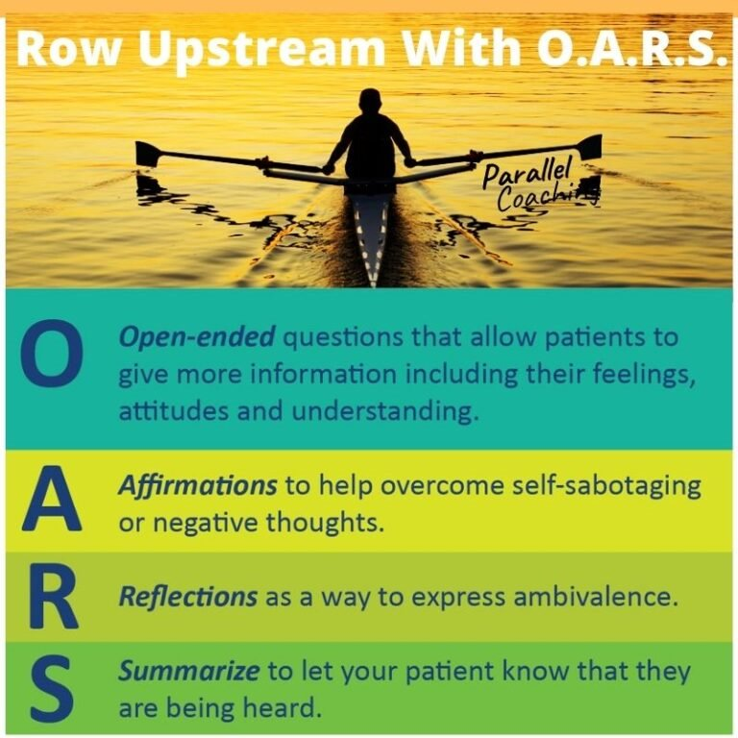



Ambivalence is Normal!!

4 Tasks of MI

Engaging Task: *Can we walk together?*

Focusing Task: *Where are we going?*

Evoking Task: *Why would you go there?*

* Why would you want to make this change? (Desire)
* How might you go about it, to succeed? (Ability)
* What are the three best reasons for you to do it? (Reasons)
* How important is it for you to make this change? (Need)
* So what do you think you’ll do? (Commitment)
* What are you considering? (Activating)
* What have you already done? (Taking Steps)

Planning Task: *How will you get there?*

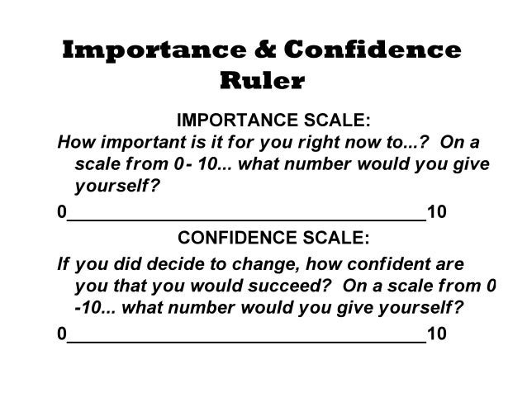

Ask – What have you already tried?

Offer – Can I tell you want I know about…

Ask – What do you think?

When Unsure What to Say…

**Elicit** Change Talk.

**Reflect** what you hear.

Be **Genuine** and **Curious**.

**Partnership**

**Acceptance**

**Compassion**

**Empowerment**